**Development updates**

**Week5**

After the first meeting with my group, we had some ideas of "Smart Fridge".

This is our original idea:

Our project is divided into 3 parts. The first part is the camera. The camera is linked to the computer. The purpose of the camera is to identify the food information that has been put in the fridge. For example, if we put the banana into the fridge, the camera can recognize that the banana is placed in the fridge and then transfer the information to the computer.

The second part is the transmission of the image. The computer can identify the food we put in the fridge by identifying the QR Code of the food package. And the computer also can know the food shelf life.

The third part which is displaying the food on our phone. The user can know which kind of food exists in the fridge through the mobile phone, and the shelf life of the stored food. The advantage of our product is that you can know what food stored in the fridge without opening the fridge door. It will waste electricity if we always open the fridge door. Using our products will save more power and is friendly to the environment. And the users can easily see the shelf life of food, people often forget the food shelf life, they have to throw away the food when the food expired, if they use our products would reduce waste.

In order to compare our product with those already sell on the market, I searched some products which are similar to ours. There are many differences between our product and others. I found the shortages and advantages of our product. If we want to win the praise of consumers, we must innovate.

A similar product to us is the Samsung Family Hub, which is also a smart fridge, but its operation methods are different from ours. The camera in Samsung's smart fridge can project food’s pictures to the big screen on the fridge door. Food can be tagged and tracked by users, and the fridge can help users remember where the food is. The user needs to manually enter the shelf life of the food, and if the food expires, the fridge will alert the user. The difference between our products is that we can automatically identify the type and shelf life of the food. Our products can let the user know the dynamic information of the food more quickly, clearly and conveniently.

**Week6**

After talking to Stavros on October 24th, we made some improvements to our product. There are improved thoughts.

The Smart fridge has two ways to identify the food. The first method is that installed the camera on the fridge door because when the user puts food into the fridge, opens the fridge door is an indispensable step, so we think that install the camera on the fridge door is a reasonable way.

The IR Sensor is triggered when the user is holding the food in front of the fridge. The IR sensor will send details to the camera, the camera will take photos of the food, and then call the Google Cloud Vision API identify the information of the food. After the food is identified, in order to ensure the accuracy of identifying, we added a weight sensor to the fridge to ensure whether the identified food is correct by weighing.

Because the first method has a lot of uncertain factors, such as the problem of light and the problem of the user's finger’s occlusion shadow, it can't be 100% accurate. In order to avoid the fridge will identify the wrong food, we also provide another way to identify the food. The Smart Fridge also can scan the QR Code on the packaging of food, then it can call the Tesco API to identify that.

If we install a weight sensor in different locations in the fridge, it means that we can know the exact location of each food without opening the fridge, because the weight of each food is different. It also means that we need not scan the food when we take it out, and the fridge knows that we took out what kind of food.

At the same time, the Smart Fridge can tell the user of each food's shelf life and today's date. And the Smart Fridge can also help the user to calculate the optimal eating time. This function can save the user from opening the fridge door to see the warranty period.

Always opening the fridge door is also a method of wasting electricity, so this function saves time and power. At the same time, the weight sensor is installed in different positions in the Smart Fridge, which means that we can know the approximate location of each food without opening the fridge.

These are our recent thoughts and improvements in our product.

**Week7**

I did some work of interface design. I hope that the interface of our product could have some new ideas. I think there is a very important link between users and designer. The interface design plays a great part in communicating with users directly. So, it is crucial. The quality of the interface design will influence the user’s subjective feeling and if they want to open the game to play. In other words, if the user does not feel good when entering the web page, which product is also difficult to attract users.

The interface design also includes the culture and personality of a product. For example, some well-known large companies, such as Apple, their interface designs are not only making the users feel comfortable and smooth but also have distinctive features. Even when users see the pages of these websites, they know which company made them.

At the same time, the page design also serves as a guide. A good design will help users to operate more easily and quickly. If a page has multiple functions and clear, it is very beneficial.

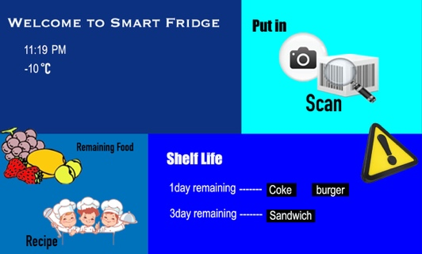

There is the first interface I made. I used 4 different blues color making the background color. The first visual element of the product interface is the color, and the color will affect the user feeling.

This interface is divided into 4 modules, and the module in the upper left corner marks the time and the temperature inside the fridge.

The module in the upper right corner is the scanning module. Click on the scanning module to start scanning food, then put the food into the fridge, the fridge can record the food which put by the user.

The module in the lower left corner is about the remaining food in fridge and recipes. The system will show the user the remaining food in the fridge, and the fridge will provide a recipe for the user. The user can decide the type of meal and recipes recording to the remaining food, it will be more convenient and smarter.

The module in the lower right corner is a module for the food shelf life. The smart fridge can remind the user of the shelf life of the food. Because there are many foods in the fridge, sometimes the user forgets the shelf life of the food. The food passed the shelf life and had to be thrown away. The exclamation point in the interface is also avoided wasting.

In order to make an easier menu, I used some cartoon icons to help users to distinguish the function more easily. I try to make my page design simple and clear, although the fancy layout and the multi-page mode may be tempting, the user will feel inconvenient and confused. When the page design is simple, users can see our products or services more clearly. I think it's very important to stick to simple page design.

But this design I ignored the importance of typesetting. Typesetting is very important in the shaping of Interface designing, and it will affect the practicability of the page. This design layout is very irregular, and there is no systematic typesetting. It makes the user do not know how to use it after opening the page. The user did not classify each function. The page design is very confusing and does not reach the purpose that gives the guide to the users. I had to re-design the interface, I summarized the advantages and disadvantages of the first design.

**Week8**

This week, we had some problems with QR code recognition. We originally used the camera that came with the computer, but the camera was not specifically used to identify the QR code, so we tried to find a new camera. And the Raspberry Pi has an obvious stuttering phenomenon.

I found the fridge this week, but it was just a 4L fridge. Although it was very convenient to carry, we thought this fridge was too small so that it could not even fit our products. So, we replaced by a 16L fridge.

We need to build a database and each user will have a separate ID. The fridge will record the recipes that the user has used before and sent them to the database. The database can collect the user's preferences. If the user wanted to try a new recipe, they would need to search for it in the database, and the database would also record the new recipe searched by the user. The information for each fridge will be sent to a cloud database, which is then analyzed by data from 100 people in each country. It will count the foods that people in every country like and dislike. After the statistics, when the user uses the fridge, they can directly select the country, and then the database will show the food that people like in that country.

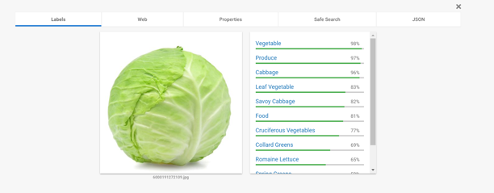

The advantages are that the recipes in each user's fridge are different, and they are all customized according to the user's preferences. The database also collects Mx-Serving, Energy, Fat, Saturates, Sugars, Salt, Allergens for each ingredient in the fridge.

**Week9**

This week, I redesigned the interface. I changed the style to design the interface. I tried to make our product interface design more modern because our product is about smart home, obviously, modern style is more suitable. I hope that users will think it was a smart product from the interface design, and I also added some elements of ink style as a background, such the combination of classic and modern, the combination of the East and the West. It will make our interface more beautiful.

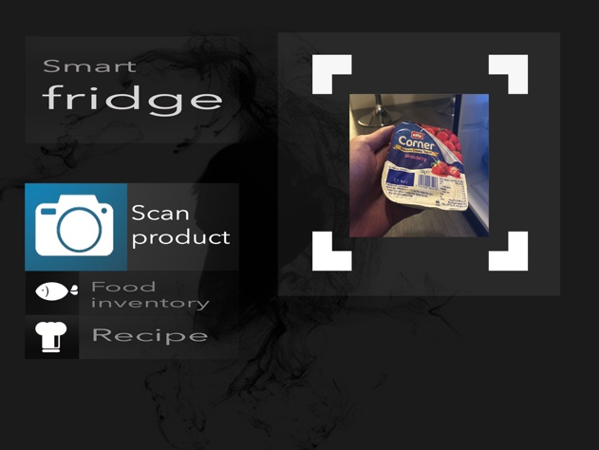

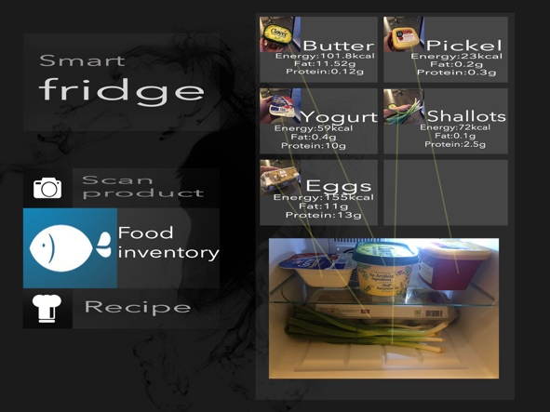

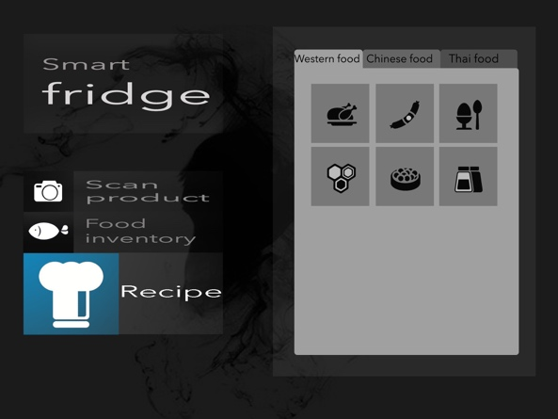

I designed the button as a crystal glass button. The last page design used blue, but I think there are many brands in blue, and we can't make our products profound and impressive to users, because of the apply of ink style, so I made the theme of the page into three colors: black, white and grey. The advantages of black and white, which make people feel elegant and stable.

On the left side of the main interface are 3 crystal buttons that guide the main functions of our product. Click any button to bring up the specific function on the right side of the main interface. When the button is clicked, the color of the button will turn blue.

**Week10**

This week my task is to make a box by 3D printing, the purpose of the box is to package our products.

First of all, my team members told me the size of the box I needed to make. I found some references for 3D printing on the web. I needed to make the 3D model and make it through software, such as SketchUp, 3ds MAX and MAYA. I intend to use MAYA software making the model.

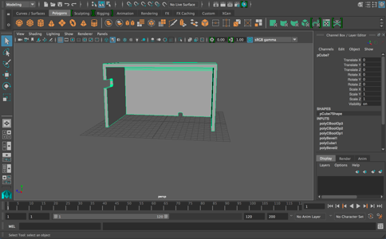 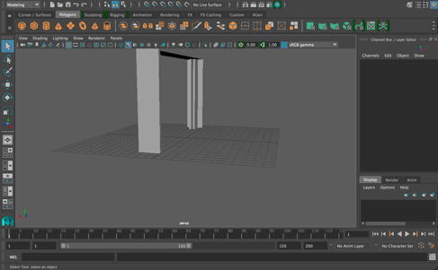

The 3D model was mainly divided into 3 parts. Then I bought a 3D printed material on Amazon. I asked Stewart to help to use the 3D printer, then I converted the MAYA file to an STL file and started 3D printing on Thursday. The printing time was about 13 hours.

**Week11**

We made a presentation in class this week, and Stavros gave some suggestions to us, he suggested that we could make some improvements to the interface. And we also could use a tablet to display. We originally had three interfaces, but we didn't have the main interface. So, I need to make the main interface.

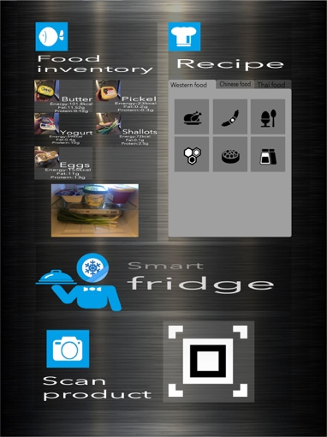

I hope to combine the 3 interfaces that I could make into one interface. I use metal material as the background. The interface is mainly divided into three parts. The top left corner is “Food Inventory”, the upper right corner is “Recipe”, and below the picture is “Scan Product”. The specific function was similar to the previous design.

I also designed a logo for our product. It is a cartoon style of food. The cartoon character's head is a snowflake pattern, indicating that it is a fridge’s logo. This logo will let users feel that our product is not only a fridge, more like a smart housekeeper.

I improved the interface. I picked up 3 modules into the interface in order to make the product easier to operate. I made 3 different interfaces so that we could discuss which one we used in the final.

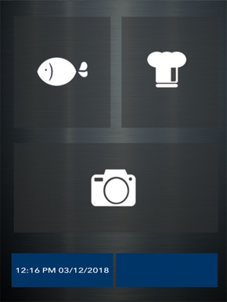 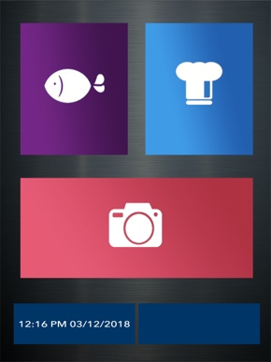 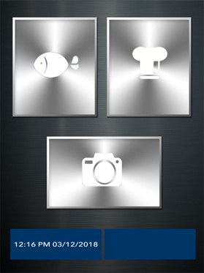

The first interface design is based on metal material, because our fridge is also made of metal, so I think that using this material is suit for our product-fridge. The three buttons are still translucent gray, and the buttons have own function icons.

The second interface is that I used three colors, red, purple and blue as the color of the three buttons. The three distinct colors will produce a strong contrast and will give the user a very deep impression. After long-term using, users can distinguish features directly based on color.

The third interface is also a metal element. The buttons are also designed with a metallic texture through the PS. The metal that looks cold and beautiful.

After our discussion, we think the second one is more suitable for our product, so we chose the second interface as our main interface.

**Week12**

The screen of the Raspberry Pi we used was a bit small, our interface looked not pretty good, so we tried to display it with a Samsung tablet. Unfortunately, the 3D printed box I made for the Raspberry Pi has not come in handy, but I had some new missions. My tasks are to make 3D printing for our packaging for our product including wiring parts. Although it is a small device, I hope I could make it beautiful and attractive.

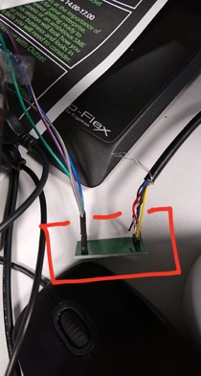 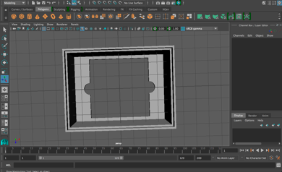 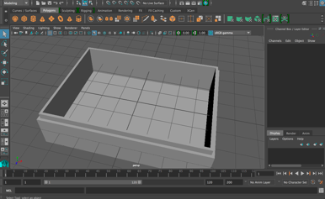

**Week13**

This week our product has been basically completed, and the design of the interface has been presented on the display screen of the tablet.

We decided to place the tablet above the fridge, so we needed to make a base to fix the tablet, this is the 3d model I made with MAYA.

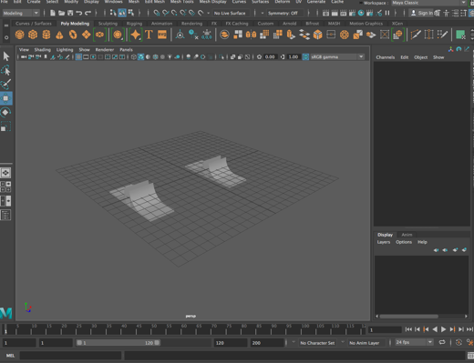 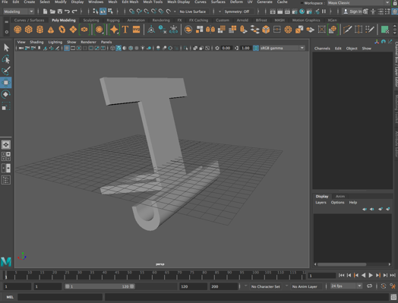

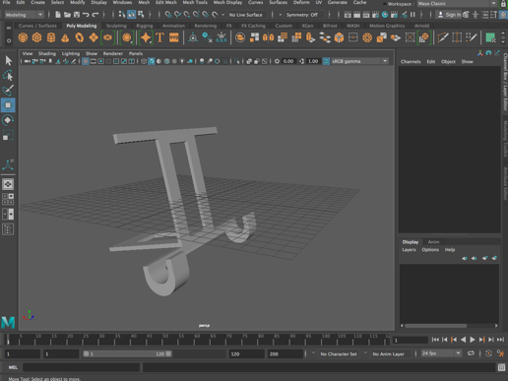 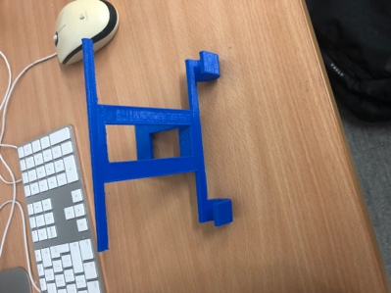

After 3D printing was completed, we began to assemble our product. We placed the fridge on the weight sensor.

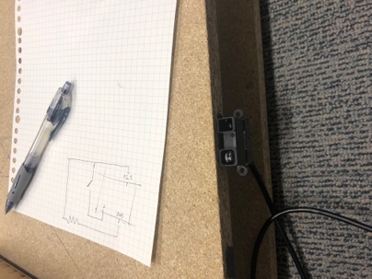

Then we installed the infrared sensor under the fridge door and installed the tablet and the base above the fridge. There is final adjustments after fixing.

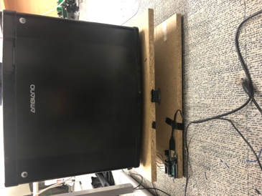 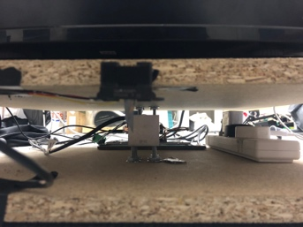 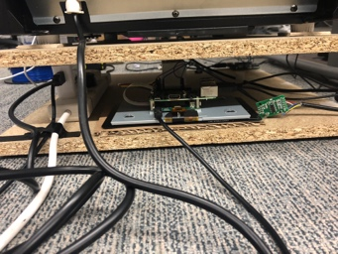

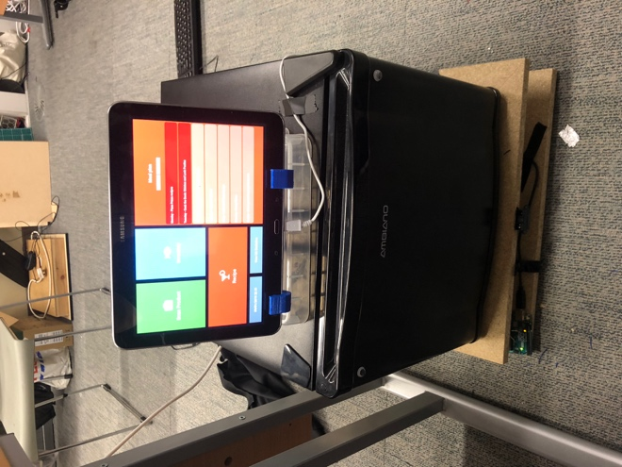

At the end of the program, we prepare the presentation. We hope our product will have good feedback.

**Reference:**

CNET,(2016). Samsung's $6,000 smart fridge is an outstanding appliance. Available at: <https://www.youtube.com/watch?v=EaKQ1aw49Pw>

Tech World,(2018). Top 5 Smart Refrigerators 2017. Available at: <https://www.youtube.com/watch?v=WTT83C3Ot4Q> [Accessed 17 Oct]

Thomas,S., Dongman,L, Bjorn,T, Seonyeong,H, Byoungheon,S, Byoungoh,K.(2014). Cloud Fridge: A Testbed for Smart Fridge Interactions.[pdf]Available at: <https://www.researchgate.net/publication/259571968_CloudFridge_A_Testbed_for_Smart_Fridge_Interactions>

Brown, M.(2016) Samsung Smart Fridge Can Watch Food Expire.[Newspaper]Available at: <https://www.ibtimes.com/ces-2016-samsung-smart-fridge-can-watch-food-expire-generate-shopping-lists-2247697>

Matthew,E. Kanisius,K,Meidia,H.(2017) Smart fridge design using NodeMCU and home server based on Raspberry Pi 3 [pdf] Available at: <https://ieeexplore.ieee.org/document/8266047/metrics#metrics>

Jose,R.(2012). The Pervasive Fridge. A smart computer system against uneaten food loss. [pdf]Available at: <https://hal.archives-ouvertes.fr/hal-00825886/document>

Luo,S, Jin,J, Li, J.(2009) A Smart Fridge with an Ability to Enhance Health and Enable Better Nutrition. [pdf] Available at: <https://pdfs.semanticscholar.org/54bb/f7ab72d7e73d002a682d5cfbaac36eb38276.pdf>

ForresKnight.(2017).10 iOS Ui Design Tips (Do's and Don'ts).Available at: <https://www.youtube.com/watch?v=KHd-h8TmFoM>

Salomon,A.(2017). Apple OS / MacOS futuristic UI concept - Edge to Edge Macbook & iPhone design.Available at: <https://www.youtube.com/watch?v=6TJr9eMXVDI>

Shillcock,R.(2013).Understanding the Qualities and Characteristics of Clolor.Available at: <https://webdesign.tutsplus.com/articles/understanding-the-qualities-and-characteristics-of-color--webdesign-13292>

Rouge.(2017). Why good user interface design is so Important.Available at: <https://www.rouge-media.com/blog/good-user-interface-design-important/>